**Big Mountain Resort Ticket Price**

1. **Problem statement**:

How Big Mountain Resort (BMR) optimize the ticket price strategy in the market context in order to maximize the return. By building predictive ticket pricing model to provide guidance for BMR’s pricing & future facility investment plans (within 1 month)

1. **Ticket price modeling**:
2. BMR in market context:

* BMR (a ski resort in Montana, US) has access 105 trails in Glacier NP & Flathead NF with 350k annual clients. BMR’s just installed a chair lift (cost $1.54mil) to attract more visitors. Pricing strategy‘s been mainly based on aver price of resorts in the maker segment while ignoring other factors like facilities utilization. Decision makers need a guidance on the ticket price’s components breakdown & predictive pricing model, by that they can define their ticket price strategy.& future investment plans.

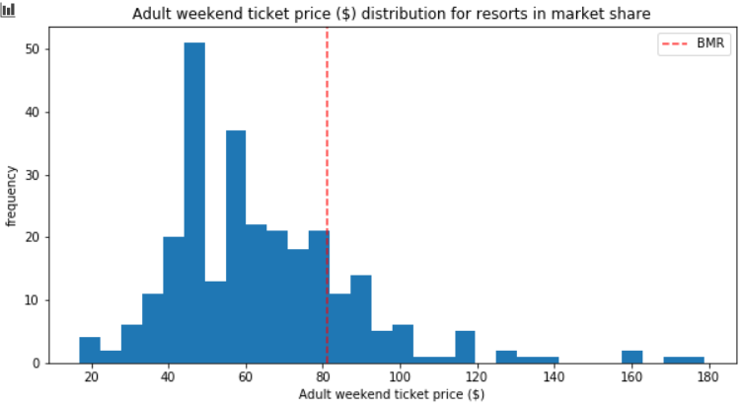

* Its ticket price is $81, the highest one in Montana region, which is over the average price in the market. On the other hand, other facilities in terms of natural incentives & infrastructure investment are also at the top rank.

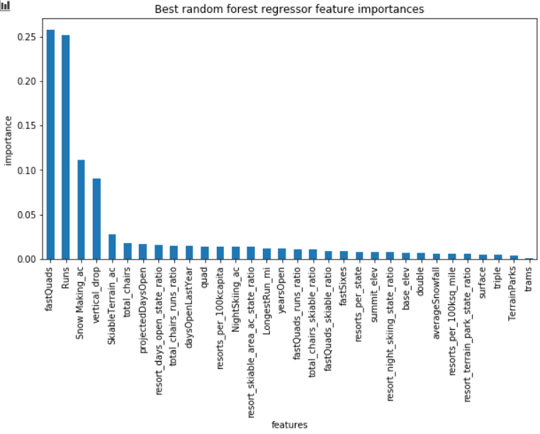

1. Regression Model:

* BMR price has been predicted is $95.87 using Random Forest model excluding BMR info vs $81 actual one. It means that it still has room to increase ticket price then revenue.

1. Modeling scenarios:

* Several features showing a good correlation to ticket price have been fluctuated so that business models are compared then assist for decision making.
* 04 modeling scenarios have been suggested basing on strategy of using these features: vertical_drop, Snow Making_ac, total_chairs, Runs, LongestRun_mi.

1. **Recommendations:**

* Model 02: Increase the vertical drop by adding a run to a point 150 feet lower down but requiring the installation of an additional chair lift to bring skiers back up, without additional snow making coverage, which is the best description of the current business status. The consequence is a suggested price increase of $1.9 leading an increasing of $3474638 in revenue over a season